Book Group Discussion Questions for Prosper in Love
By Deborah Michel
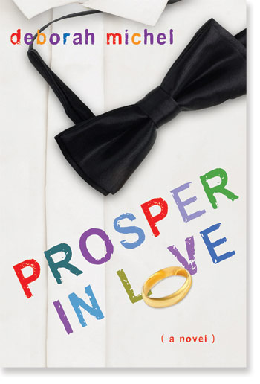

- Lynn Prosper believes that she and Jamie had an instant connection when they met—literally love at first sight. Is there such a thing as love at first sight? And if so, does it last? (Lynn herself acknowledges that sometimes you can feel that connection, yet it goes nowhere.) Does that initial connection matter at all?

- Even if F. X. had never showed up, would Lynn and Jamie have run into problems in their marriage anyway? Is their marriage a good marriage? What factors are necessary for a good marriage?

- Do you believe that an otherwise good marriage can be wrecked by external forces—by another person, for example?

- Lynn and Jamie are so different and come from such different backgrounds. Is that a problem? Are some differences are too big to overcome?

- One of the epigraphs for Prosper in Love comes from George Elliot’s novel Middlemarch: “Young people should think of their families in marrying.” Should they? To what extent? It’s also a truism about marriage that you don’t just marry your spouse but their whole family as well. How do Lynn and Jamie’s family members play into the dynamic of their marriage—both directly and indirectly?

- Lynn has a different connection with the movie director Peter Fairhaven than she has with Jamie, but it’s a strong connection nonetheless. Do Lynn and Peter make a good couple? What do you think of Lynn’s choice—and her reasons for it?

- Both Lynn and Jamie have full-time careers. What are some of the different ways their careers come to affect their marriage? Lynn comes to feel that Jamie doesn’t take her career as seriously as he takes his own. Is she right? Is Jamie in the wrong?

- There are lots of marriages and relationships in Prosper in Love. Which ones struck you as happy, “good” ones?

- And how about the novel’s ending? What sort of future do you imagine for Lynn and Jamie?

